Lab 12 - PostgreSQL

Neven Said
Lab 12 (Thursday, May 1st)
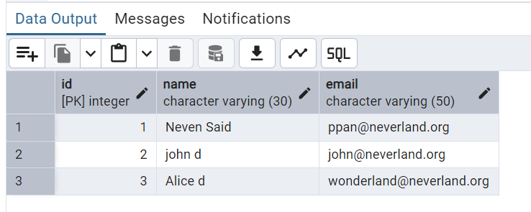

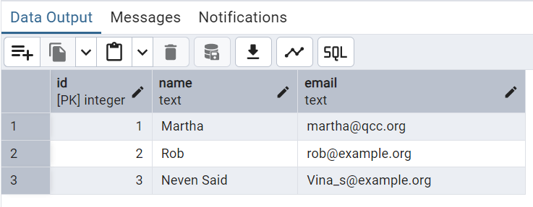

Lab exercise 12B
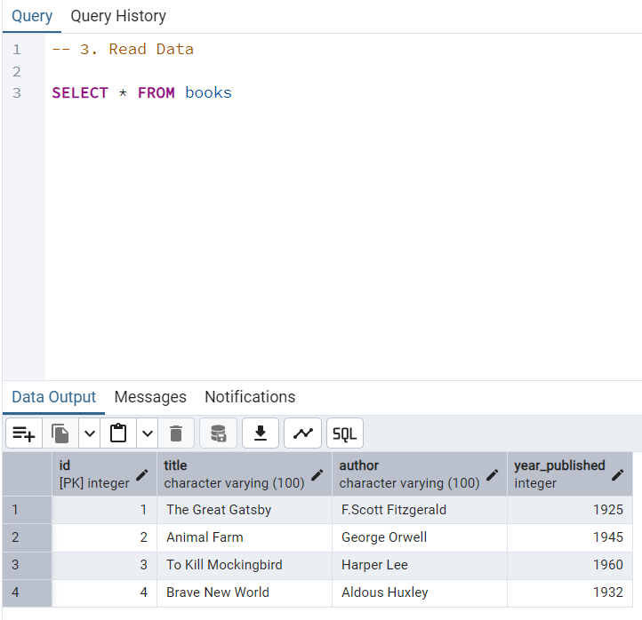
3. Read Data

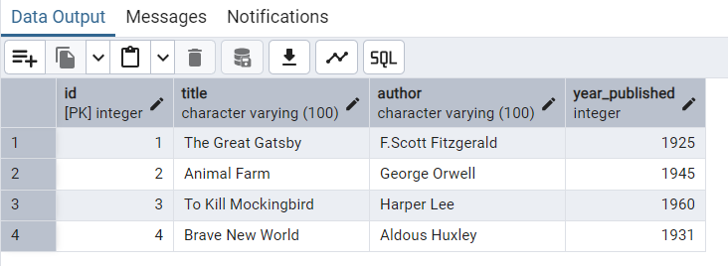
4. Update Data

5. Delete Data and Final Table
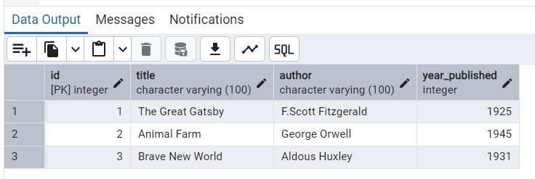

Bonus Challenge
